Purpose: PHP script to capture user profile attributes set in HTTP headers by Apache Web Agents. Reads the required header value from the http headers and stores it into the edi table which is used later in the application for retrieval. A unique id is generated and passed to the application URL to identify the session.

- Install PHP (Refer the install guide – section A.4 for software installation)

- Add the following PHP script (bcagent.php) to the required site (/var/www/html).

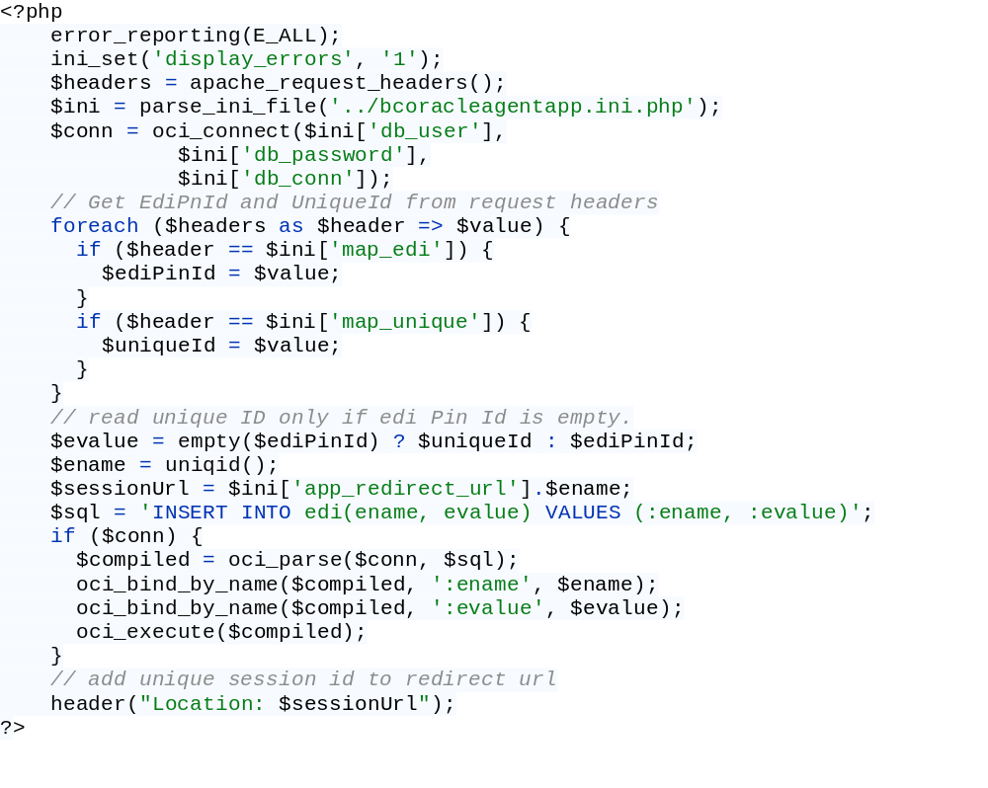

Code Explanation
- error_reporting (E_ALL): This is a built-in PHP function that is used to display PHP errors.
- ini_set(‘display_errors’,1): This function will override the configuration set in PHP ini file. Here, the display_errors directive is set to ON to display errors.
- apache_request_headers() : array | false
    - Fetch all the HTTP request headers and returns an associative array of the headers in the current request. Returns false on failure.
- parse_ini_file(): array | false
  - Loads the ini file specified in a filename and returns the settings in an associative array.
- oci_connect: Connect to an Oracle database by passing username, password, and connection string.
- foreach : Construct that provides an easy way to iterate over arrays. For each loop iterates over the header names and stores the header values for the header names stored in map_edi and map_unique variables from ini file.
- If unique id is available, store in in evalue variable or store edi pin id.
- uniqid(): strng: Generate a unique id.
- Concatenate the unique id from step 8 to app_redirect_url value.
- Execute the INSERT INTO edi table statement.
- header() : void
  - Used to send raw HTTP header to browser (redirect URL).

- Add the PHP.ini configuration file to the site (/var/www/)

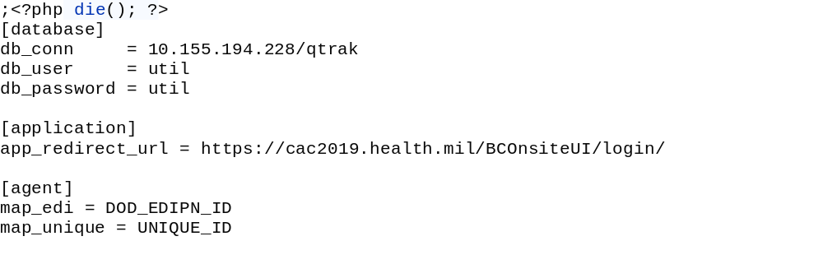
Code Explanation:

- [database] : provide oracle db connection details
  - db_conn: DB url/DB SID or service name
  - db_user: username
  - db_password: password
- [application]: Provide application server URL. Refer Notes section at the end for the specific changes that each application requires.
- [agent]: Provide the HTTP header names to monitor.

- Restart the Apache HTTP server.

- Navigate to the script : http://<HttpServerIP:HttpServerPort>/bcagent.php

- After successful authentication, the HTTP headers are retrieved, and the browser is redirected to the application server URL mentioned in the .ini configuration PHP file.

Notes:
Application-specific changes:
- Oracle Application – Edge browser.
  - bcoracleagentapp.ini.php

Use the application server URL as highlighted below. Include the URL in double quotes and add the “jsessid=” URL parameter to the application server URL.

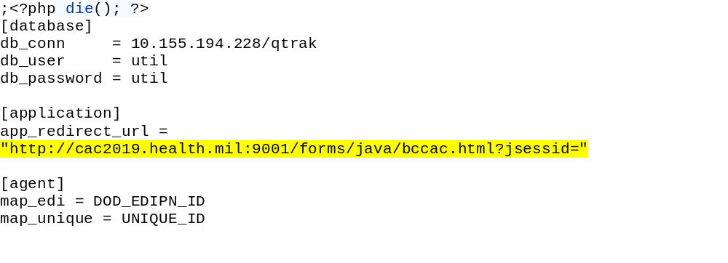
  - bcoracleagentapp.php
Pass the ini configuration file to the PHP script.

- Oracle Application – browser less.
  - bcoracleagentapp.ini.php

Use the browser-less application server URL as highlighted below. “bcvbs://” is the custom URL protocol handler for the application.
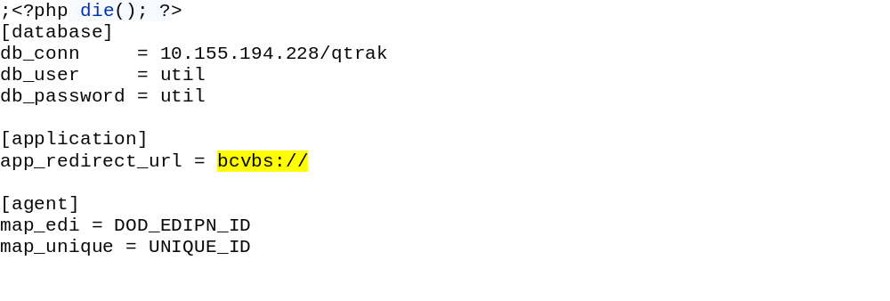
  - bcoracleagentapp.php
Pass the ini configuration file to the PHP script.
- BC Onsite Application

  - bcagentapp.ini.php

Use the Onsite application URL as shown below.

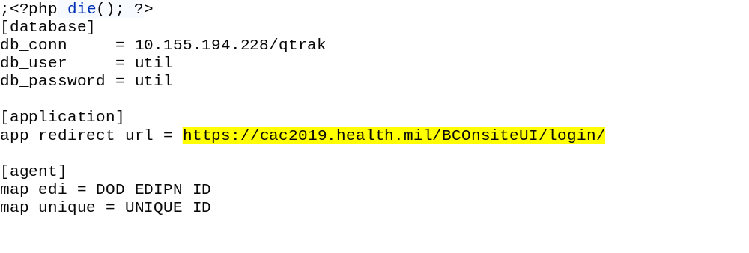
  - bcagentapp.php
Pass the ini configuration file to the PHP script.

